- I created two datasets: one with samples that have data for all blubber depth (surface, medium and bottom) for either hormones. 19 individuals total

 |  | Cortisol ng/g |  |  | Corticosterone ng/g |  |  | Aldosterone ng/g
Blubber Depth | Sex | mean | standard deviation | range | mean | standard deviation | range | mean | standard deviation | range
Surface | F | 11.33 | 14.24 | 43.80 | 1.48 | 1.20 | 3.01 | 0.34 | 0.53 | 1.47
Medium | F | 4.83 | 6.22 | 16.83 | 0.76 | 0.47 | 1.24 | 0.05 | 0.03 | 0.09
Bottom | F | 8.58 | 9.11 | 27.63 | 0.71 | 0.62 | 1.68 | 0.05 | 0.04 | 0.10
Surface | M | 3.89 | 4.06 | 9.75 | 0.56 | 0.63 | 1.92 | 0.07 | 0.04 | 0.09
Medium | M | 2.95 | 3.58 | 10.44 | 0.79 | 0.69 | 1.72 | 0.07 | 0.11 | 0.25
Bottom | M | 3.06 | 3.70 | 10.45 | 0.59 | 0.37 | 1.03 | 0.11 | 0.21 | 0.43

For cortisol:
17 individuals with complete profile (i.e. hormone concentrations for all three layers) + 2 individuals with concentrations from 2 out of three layers.
To test the effects of blubber depth on cortisol concentrations, I fitted a mixed effects model where individual are counted as random effects ( repeated measures ) and blubber depth (and sex) where tested as a fixed effects.
The output of the models indicated that the model including the interaction of blubber depth and sex to be the best model (lowest AICc). However, the post hoc test of marginal means did not indicate any significant difference in any combination of blubber depth and sex. Note: what there are two major outliers in the surface layers (both females).

Figure 1: Cortisol concentrations across blubber depth. The model including the interaction of blubber depth and sex was identified as the most predictive factor for hormone concentration; however, the difference among layers was not significant.

For corticosterone:
removed one individual that had data for only one layer. The analysis is done on 16 individuals for which we have complete datasets
To test the effects of blubber depth on corticosterone concentrations, I fitted a mixed effects model where individual are counted as random effects ( repeated measures ) and blubber depth (and sex) where tested as a fixed effects.
THE NULL MODEL was identified as the best model, followed by the model with blubber depth as predictor. No significant difference was found
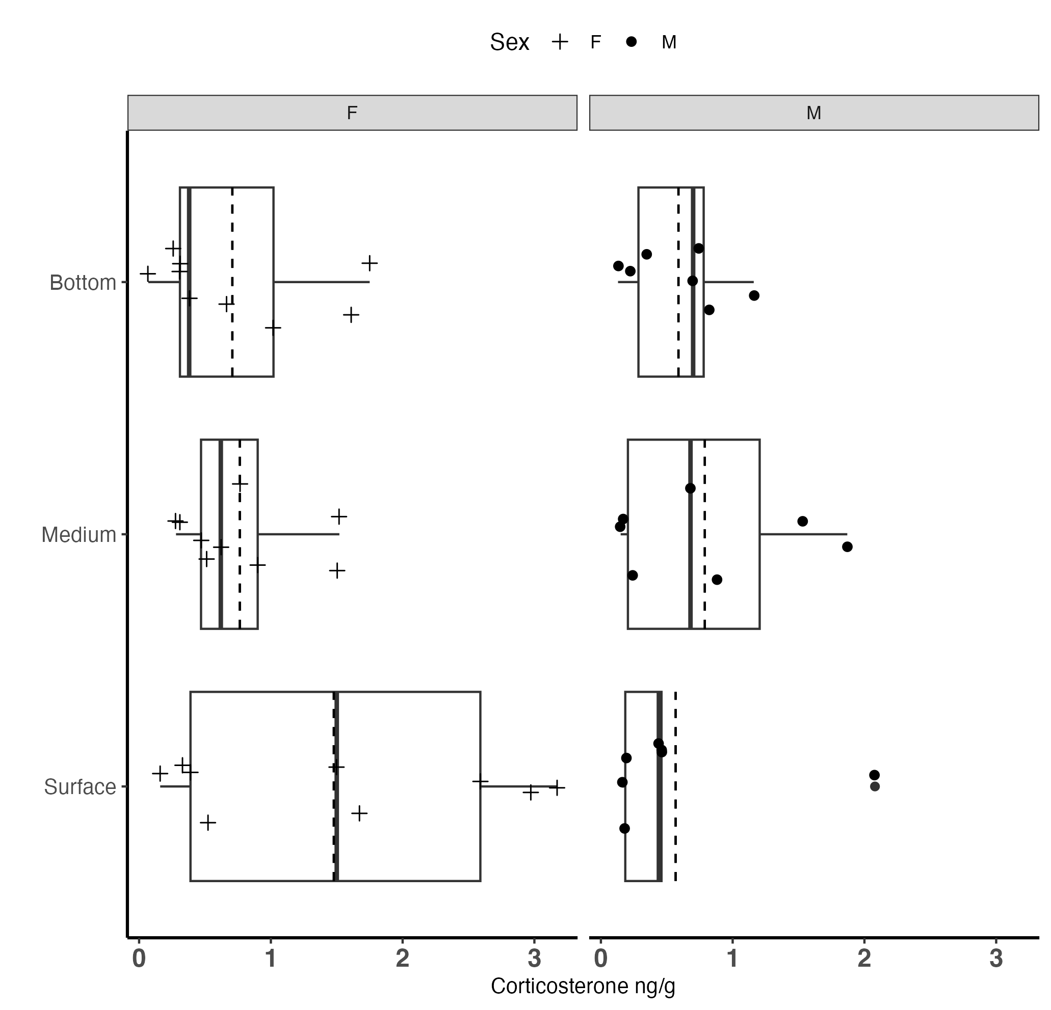
Figure 2: corticosterone concentrations across blubber depth and sex

For Aldosterone :
10 individuals with complete Aldosterone profile (all three layers) + 2 more individual with 2 out of the three layers.
The is an obvious outlier however, removing it or including it doesn’t affect the results.

With the outlier: The mean (range) of aldosterone are 0.23 80.04-1.52), 0.06 (0.01-0.26) and 0.08 (0.003-0.43) in the Surface, Medium and Bottom layer respectively.

The output of the models indicated that blubber depth is not an effective predictor for Aldosterone, aka THE NULL MODEL IS THE BEST FIT

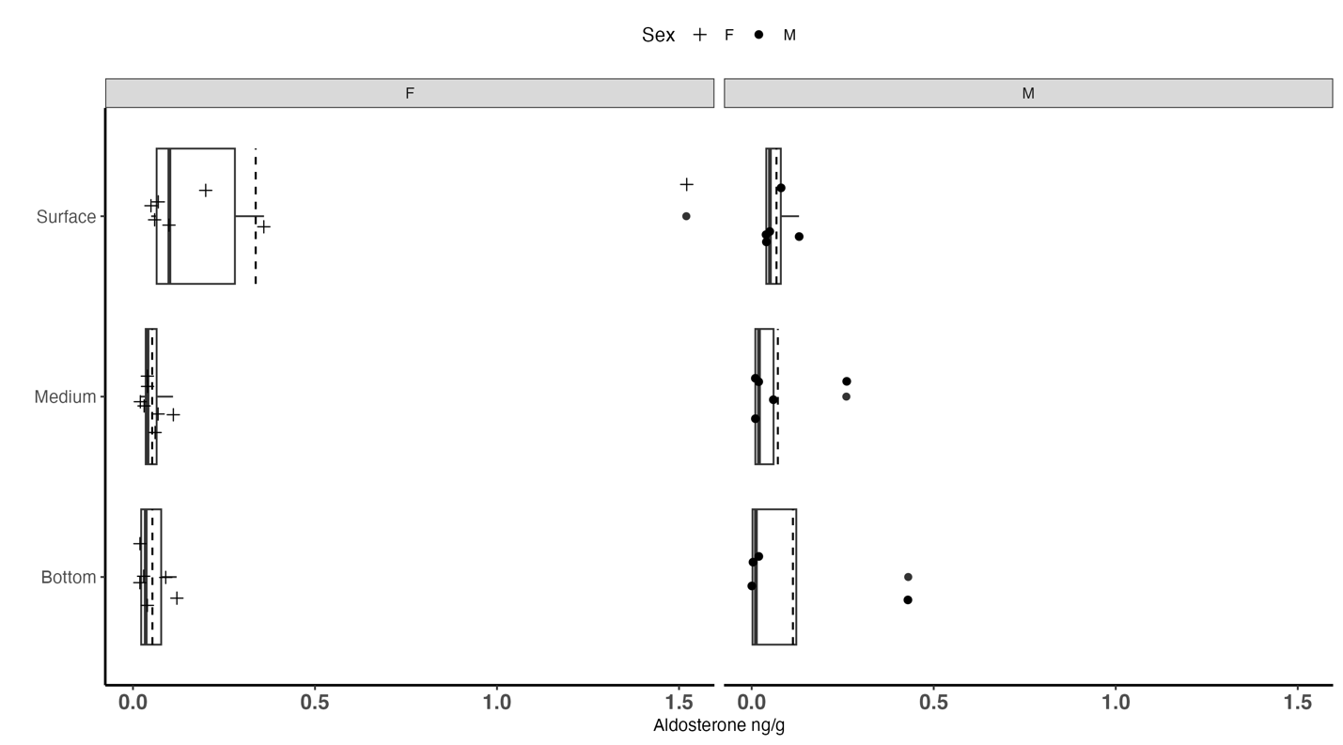
Figure 3: Aldosterone concentrations across blubber depth and sex

